Summary of Neural Network Models Developed

structCAN

Contour Adaptation specific Neural Network Model. Translated from Gregory Francis's lightness adaptation MATLAB model into Python and then developed further by including White's Illusion into the stimuli and optimizing the various modules. This model is an extension of Stephen Grossberg's FACADE model in it attempts to closely mimic neurophysiological findings as well as using complimentary boundary and feature contour systems to create the percept. The network chain processes the black and white colour channels only.

Code Overview:

Component name | What it does computationally | What it replicates physiologically
Createstimulus | Creates an NxN gray-scale stimuli at each time step, with the option of adapters. | The time dependent supply of retinal images (no processing)
LGNcells | Convolves the white-black channel of the stimuli with an excitatory and inhibitory 2D Gaussian filter. These filtered components are then combined. | Imitates the On-Off /Centre-Surround/ Exitatory-Inhibitory receptive field nature of the LGN cell.
simpleCell | Applies a bank of ODOG filters & half wave-rectifies the output. | Introduces orientation specificity to the image analysis as observed in simple cells.
- complexCell | Equal (polar) orientations are summed, a boundary signal threshold (V=25) is introduced and a tonic input is added. | Replicates pooling of information observed in the complex cell.
gateComp | Solves the mass action differential equation, as initiated by the equilibrium state of the gate response at t=0, with only tonic input. The solution evolves depending on the input signal and gating parameters. | Habituating neurotransmitter gates having two modes of action: Tending towards saturation (V=20) and depletion of the gate with the presence of a signal. i.e. gates deplete when adapters present.
dipoleComp | Combines the oriented boundary signal and gate signal with a cross-orientation weighting, creating gated-oriented-boundary signals. | Simulates two competing processes of cross-orientation channel inhibition as well as iso-orientation channel excitation (within-pixels)
fillingin | Two pixels are connected when there is no orthogonal boundary between them, this algorithm is applied to a pixel's four nearest neighbours. | Filling-In-DOmains are found by looking for connected boundary pixels, the gray-scale value is then averaged across these regions.

Gated-dipole circuit

Further model details:
Francis,Kim (2012) -Simulations of induced visual scene fading with boundary offset and filling-in.

BEATS with dynamic normalization

Bigger-EATs-Smaller is an algorithm which finds global extremities of lightness via local interactions. For example, local storage of a maximum gray value extended to it's local surround will overwrite their gray values if it is larger. In this way, as seen below, the global maximum and minimum lightness values can be extracted from an image for normalization purposes.
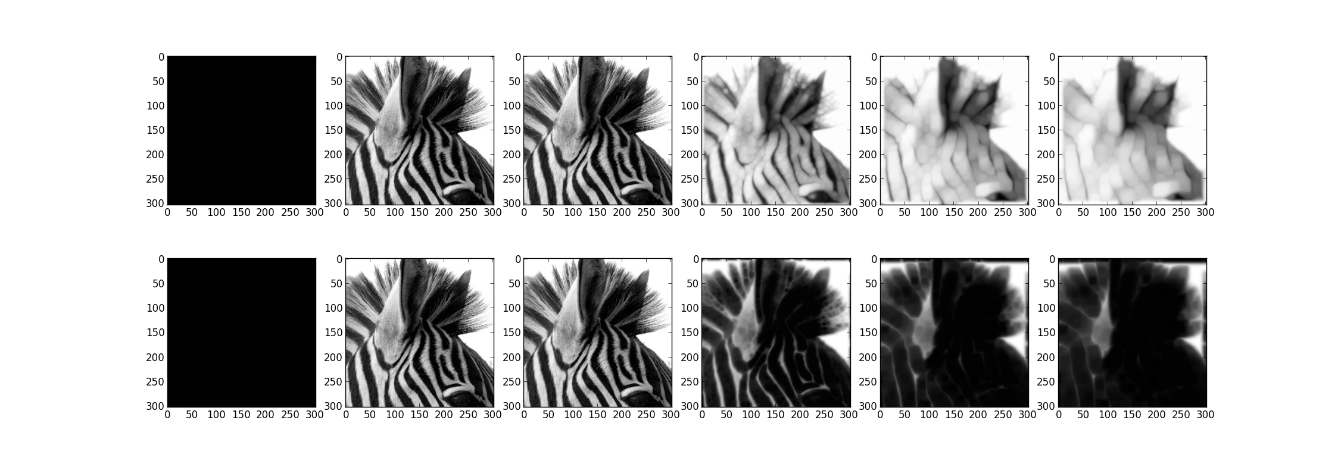
The globally max/min images are then incorporated into darkness/lightness, filling-in, diffusion layers to recreate the output image. This is called the “dynamic normalization network”.
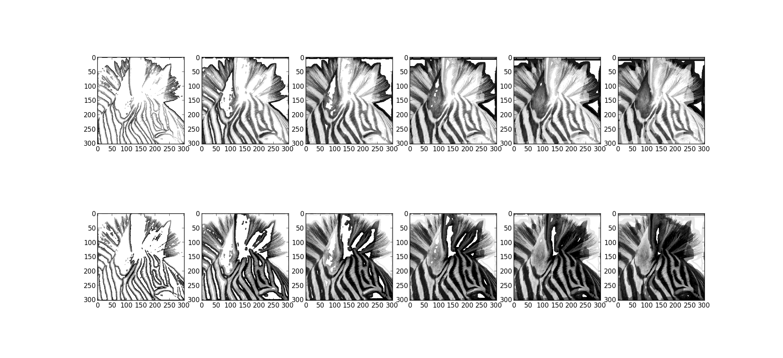
The interesting feature of this process is that the final lightness values are extracted from high-pass (single-scale) filtered image information. As seen above, colour signals “fill-in” from edge signals. i.e. edge contrast is used to compute lightness.

